Chip back potential is the level which bulk silicon is maintained by on-chip connection, or it is the level to which the chip back must be connected when specifically stated below. If no potential is given the chip back should be isolated.
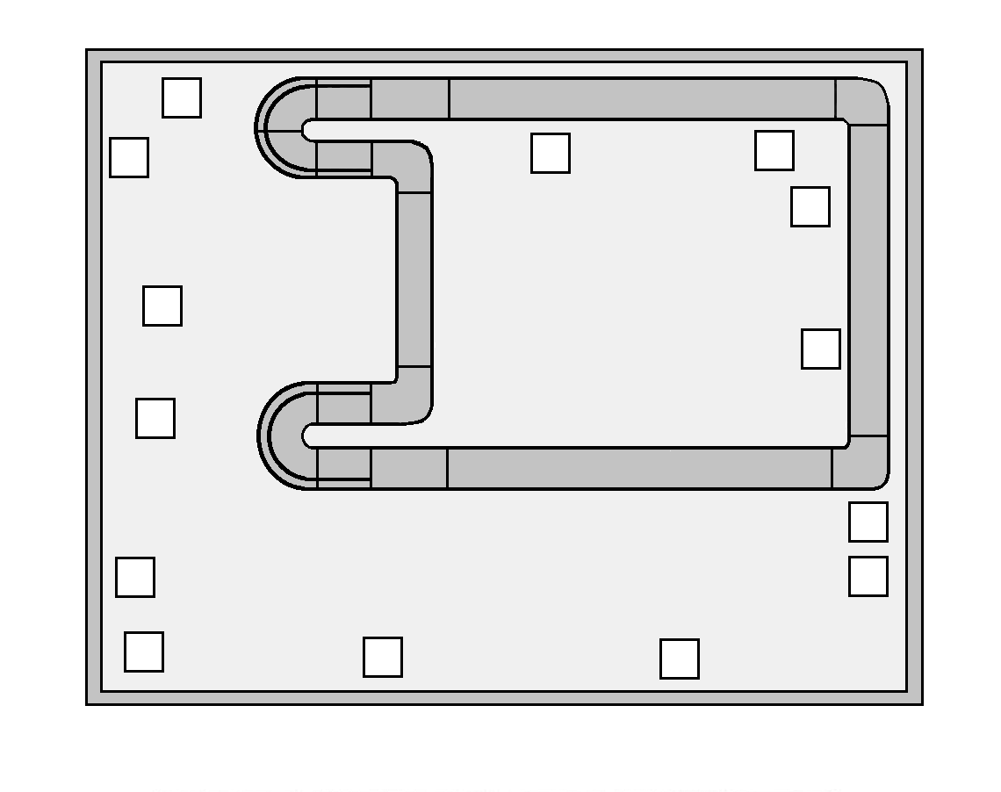
2110
2113
REV01
IRS2110_REV00
IRS2113_REV00
MASK
REF
VSS
VD
DZ
VDD
HIN
SD
LIN
LO
COM
VCC
VC
CZ
VS
VBZ
VB
HO
NOTE:
Both V_{CC} and V_{CCZ} should be connected
Both V_{DD} and V_{DDZ} should be connected
Both V_{B} and V_{BZ} should be connected

.071”
.075”

Top Material: Al
Backside Material: Si
Bond Pad Size: .0039” X .0039”
Backside Potential: FLOATING
Mask Ref: IRS2110 / IRS2113

APPROVED BY: DK DIE SIZE .071” X .075” DATE: 8/30/21
MFG: INT’L RECTIFIER THICKNESS .029” P/N: IRS2110
DG 10.1.2

Rev B, 7/1

